Head Teacher: Mr A Ruffell
Fairfield Primary School
Glenfield Road
Stockton-on-Tees
TS19 7PW
Tel: 01642 581305
Email: fairfield@sbcschools.org.uk
www.fairfieldprimary.org.uk

Dear Parent/Carer,

If your child needs to stay at home to isolate then they will still need to keep learning to avoid falling behind (as long as they are feeling well enough to do so). Your child’s teacher may be in contact with you to let you know about any specific work that they would like your child to complete.

In addition, you can access the Oak National Academy. The Oak National Academy provides a series of on-line lessons that have been planned by specialist teachers and it has been specifically designed for pupils working at home.

The topics covered will sometimes vary from those set in school, but all content follows the age appropriate National Curriculum. We would strongly advise all children to follow the scheduled lessons for their year group for the time that they are off.

Here is an example of what the lesson schedule page looks like:
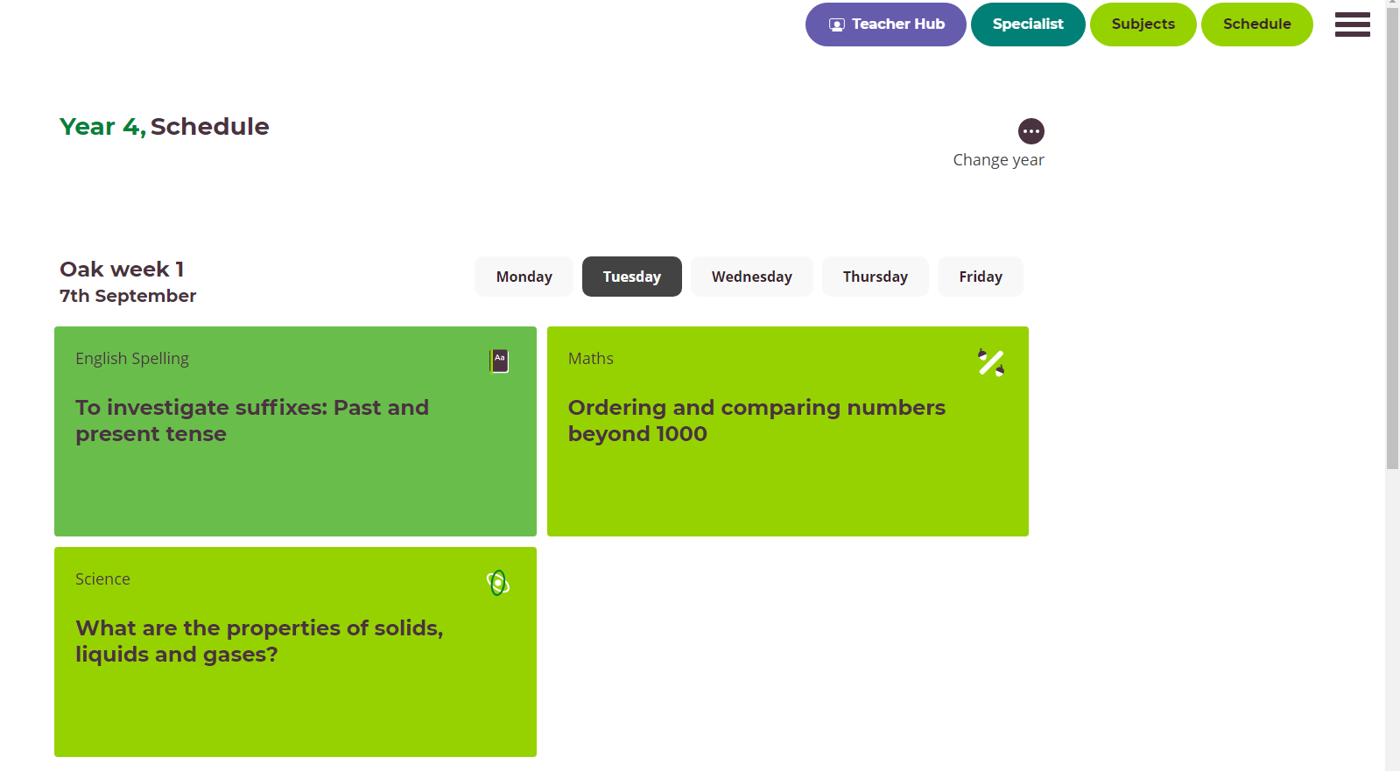

The scheduled lessons consist of daily lessons with videos and activities and each day follows a well-planned sequence of learning. If your child struggles with the scheduled lessons for their year group, it is fine to try the lessons from a lower year group – we do not want them to worry or struggle.

If they want to, they could also browse any of the other lessons or activities on the website. Many of our afternoon topics are covered.

In the online classroom each lesson is up to an hour-long. They are delivered by a teacher, with a pre-recorded video as well as quizzes, worksheets and creative activities. It’s all easy to use, there’s no login or password, you can access the lessons on any device, and you only need materials that you can find at home.

Please visit the following website: https://www.thenational.academy/

1. Click on the ‘Lessons’ tab under the Pupils heading.
2. Click on schedule.
3. Click on your child’s Year Group.
4. Locate the current week.
5. Click on the current day and start your lessons.

Other key resources to support you:

Please also remember that children in most classes will also have logins for MyMaths (which provides lessons and activities for children in Years 1-6), Lexia (to support reading and spelling), Times Tables Rockstars (to support learning of times tables and key maths facts) and Reading Plus (for Years 3-6 to support with reading fluency and comprehension).

Not all children will have access to all of these resources, but if you are unsure of what is available or what your child’s login details are, please call school.

Of all of these resources, Reading Plus and Times Tables Rockstars are particularly useful. The children who used these regularly in lockdown made exceptional progress (several children who used Reading Plus throughout lockdown managed to improve their reading comprehension ability to levels expected of children many years older).

For the children in Reception, Year 1 and Year 2, www.phonicsplay.co.uk is an excellent website with games to play to help children with their phonics. Please go to the parent part of the website. Phase 2 and 3 are suitable for reception and phases 3, 4 and 5 for Years 1 and 2.

We are also in the process of trialling a subscription for online reading books with Collins (Big Cat books). For the children learning phonics, each reading band is accompanied by a helpful video on how to make the most of reading and using phonics at home. The advice is targeted at the level your child is working at.

If you have any further questions please contact school.

We hope you make the most of your online learning and we look forward to seeing you back in school soon.

Best wishes,

Mr A Ruffell

